## Sentiment Scope: Real-Time Sentiment Analysis Across Social Media Platforms

**Group - 8**

**Team Members:** Jaylen Neduelan; Sekhar Lanka; Anjali Madhavi Nakirikanti; Uha Nikitha Rachapalli

**Github**:<https://github.com/Anjalimadhavi98/Team8>

#### Motivation

The primary goal of this project is to discover public opinion on a number of various subjects on social media platforms. It is the result of the urgent need for researchers, entrepreneurs, and policymakers to navigate through huge amounts of unstructured material in order to find the truth. Online influence has become more popular in the digital age, affecting political stories, policy directions, and brand images. This effort aims to use advanced machine learning and natural language processing techniques to manage the intricacies of online communication as social media becomes the forum for public conversation. The effort attempts to provide stakeholders the information they need to make decisions, change approaches, and interact with the public by collecting valuable insights from the noise.

#### Objectives

* Develop a robust sentiment analysis model capable of accurately classifying sentiment expressed in real-time social media live streams across various platforms and languages.
* Implement a scalable and efficient data collection and preprocessing pipeline to gather live streaming data from social media platforms while ensuring data integrity and compliance with privacy regulations.
* Evaluate the performance of the sentiment analysis model in real-time scenarios, focusing on metrics such as accuracy, precision, recall, and F1 score, and iterate on the model architecture and training process to optimize results.
* Integrate the sentiment analysis model into a user-friendly dashboard or application interface, providing real-time insights and visualizations to users monitoring social media sentiment for brand reputation management, crisis response, or market research purposes.
* Iteratively refine the model based on usage and performance.

#### Significances

Sentimental analysis hold significance role in following areas:

1. **Sentiment Analysis in Real-Time for Social Media Live Streams:** Through sentiment analysis during live events, including political debates or sporting events, this research allows real-time comprehension of audience sentiment and reactions. For a variety of stakeholders, such as organizers, advertisers etc. this information is essential because it gives them quick insights into the mood of the audience and enables them to make modifications or judgments as events take place.
2. **Sentimental Analysis in MultiLingualism** **For Worldwide Reach**: In today's more Interconnected world, Companies, governments and international organizations must be able to express their feelings in multiple languages which helps to improve Communication strategies, product Localization and Customer Satisfaction based on their feedback.
3. **Trend forecasting and predictive analytics**:Predictive analytics tools such as sentiment analysis can be used to predict future trends, market movements, and customer behavior patterns. Businesses can anticipate market movements, consumer preferences, and new trends by studying past sentiment data and finding patterns and correlations. This allows for proactive decision-making and strategic planning.
4. **Evaluation of Risk and Crisis Handling**: By tracking changes in public opinion, sentiment analysis can be utilized for risk assessment and early crisis detection. Organizations can mitigate reputational risks, proactively address concerns, and lessen the effect of crises by recognizing negative sentiment trends or potential difficulties.

The successful completion of the project's objectives has a number of significant effects:

1. **Better Decision Making**: Businesses, governments, and organizations can make better judgments about marketing strategies, policy, and product development by receiving timely insights about public mood.
2. **Increased Customer Satisfaction**: Better products and services can result from an awareness of and response to customer sentiment, which will eventually increase customer satisfaction and loyalty.
3. **Competitive Advantage**: By being aware of client wants, seeing new trends, and acting fast when the market shifts, companies who use sentiment analysis well get an advantage over their rivals.
4. **Cross-cultural Understanding**: Multilingual sentiment analysis facilitates communication and interaction with a variety of global audiences, which promotes inclusivity and international cooperation. This facilitates cross-cultural understanding.

#### Solution Architecture

The figures below explain the solution architecture for achieving real-time sentiment analysis.

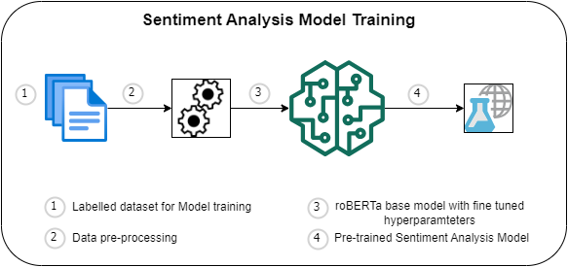

Figure 1: Sentiment Analysis Model Training flow

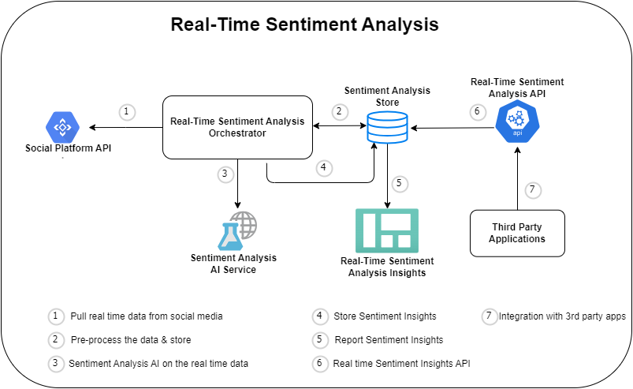

Figure 2: Real-time Sentiment Analysis Solution

#### Features

**Data Collection and Processing:**

Collecting the data for real-time processing with the integration of social media platforms using APIs.

**Sentiment Analysis & Classification:**

Analysis and classification of sentiments by employing natural language processing (NLP) techniques on collected data.

**Language Support:**

Compatibility with different languages to analyze the sentiment of diverse people.

**API Integration:**

Developing APIs for integration with different systems, platforms and applications.

**Reporting & Alerting:**

Creating dashboards, Enabling export features for reports and implementing alert functionalities when significant changes are observed in sentiments.

#### Deliverables

**User Interface:**

A user interface to interact with sentiment analysis systems which have options like visualization and customization.

**Sentiment Reports:**

Regular summary reports with results of sentiment analysis, trends and insights.

**API Documentation:**

API Documentation for developers to integrate the sentiment analysis systems with different applications and platforms.

**Maintenance and Updates:**

Maintaining and Updating the systems regularly to deliver the accuracy, ensuring the compatibility and reliability of the systems.

**Uniqueness, and milestones. Technical features of the project:**

The project will offer a unique approach by providing a compilation of social media posts from various platforms to guarantee a broad analysis of public opinions. This project will make use of an exceptionally thorough compilation of social media posts from various platforms in order to guarantee a broad examination of public opinion. The dataset's uniqueness stems from the diverse grammatical content, which includes emojis and slang and is accurately processed using developed natural language processing techniques. Achieving a high degree of annotating preciseness, finishing the dataset gathering, and developing real-time sentiment analysis capabilities, which in turn have raised the bar in the field of sentiment analysis, making this is an important milestone.